Project Name: Picky Stock Chooser

Created by: Stefan Garbev

Group ID: 1153

Project Language: C Sharp

Description: A C# program used to satisfy the pickiest stock choosers based on some non-orthodox parameter selections.

Task:

* Using a data set containing different information about stocks, create an unusual method for picking stocks. Rather than simply choosing them based on price, growth or volatility, choose them on:
  + First letter of their stock symbol
  + Country of origin
  + IPO year
  + Growth either absolute, relative or both
  + Sector of operation
* The code should be able to provide
  + Active feedback on what stage the user is and prompt them to respond accordingly
  + Ability to skip any filter
  + Notify the user of what they have just selected and what impact it has had on the data
  + Notify the user if they have filtered out all options
  + Print out to the user the full list of their selection

Main Idea:

This task was created so a user can decide on some non-traditional methods which stocks they would like to invest in. Rather than analysis on a number of numeric variables, the user will instead select based on naming, IPO year and industry, as well as some growth metrics.

This way different methods available in C# can be applied in order to filter data from a list that is read from the csv file available.

Code:

The code reads the provided csv file and then prompts the user for their input for 7 different filters that can be applied, with the filters taking on string, integer or double form. After selection (as long as the user is not too narrow on their specification) the file provides a full list of stocks that fit their request.

Example 1:

* Symbol beginning with “A”
* Country: United States
* IPO between 2009-2019
* Firm has gained $1 vs year ago
* No relative growth filter
* No specific industry selected

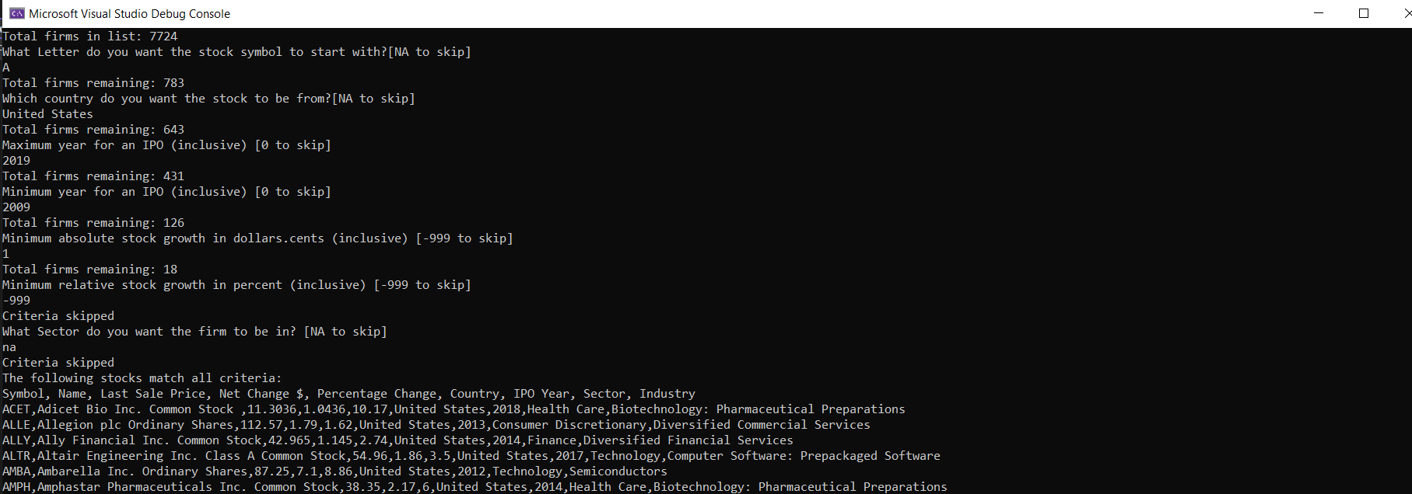

Example 2:

* No symbol filter
* Chinese firms
* Maximum year for an IPO
* Grew in absolute terms by $2
* No relative growth filter
* No sector filter

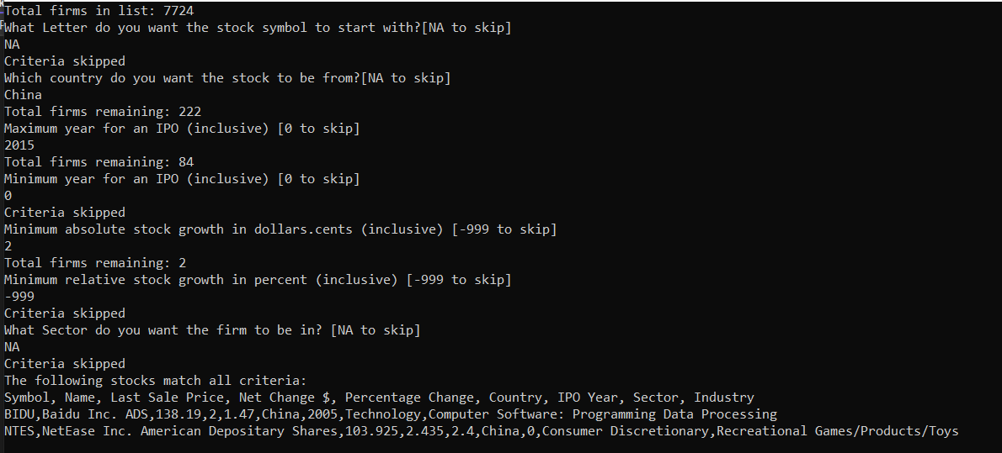

Example 3:

* Firms’ symbol beginning with “A”
* No country filter
* IPO between 1999-2022
* No absolute growth filter
* Relative growth by 2.5% vs YA
* Sector: Health Care

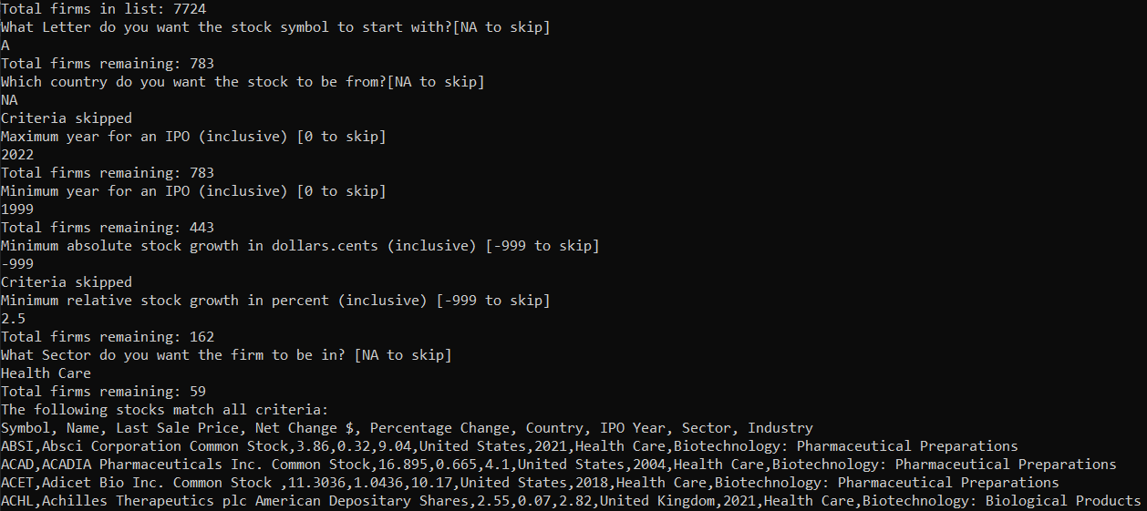

Example 4 (too narrow filters):

* Symbol beginning with “B”
* From United States
* IPO between 2009-2014
* Absolute growth $1, relative growth 2.5%
* Sector – Health Care

No results

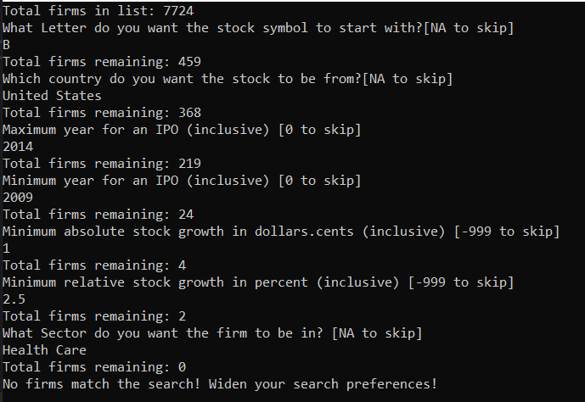

Files:  
PickyStock.cs - C# Code used to process a stock data file

NASDAQ_Data.csv – Stocks listed on the Nasdaq, including their Symbol, Name, Latest Price, Net Change vs YA, % Change vs YA, Country, IPO Year, Sector and Industry